**Smart Link**

<http://5ineprojects.com/smartlink/html/>

1. Video has been uploaded please purchase and prove the video



1. Provide the marked images size 400x600

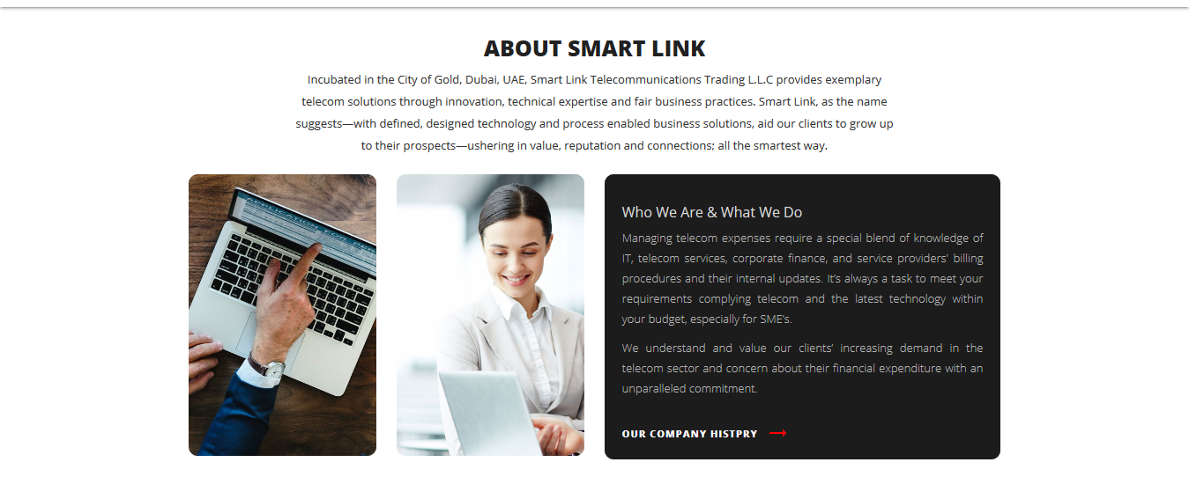

**Product & service**

1. Content is required

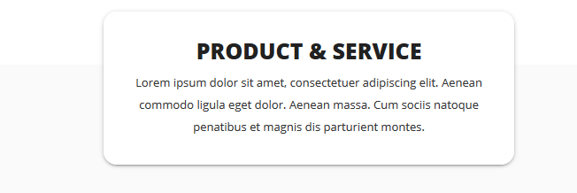

Products and service not required any explanation. Please use below template for reference to create landing page.

PLEASE KEEP A HANGING BUTTON ON RIGHT BOTTOM FOR CONTACT US!

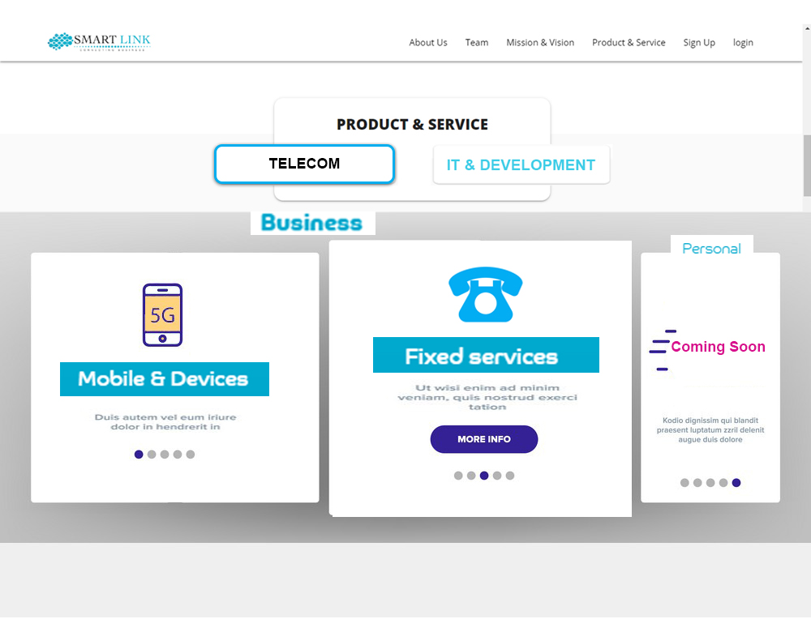

Above screen shot is a scroll towards left/right with below

TELECOM

* MOBILE & DEVICE
* BUSINESS MOBILE PLANS(please use below template, must be editable)

NATIONAL PLANS

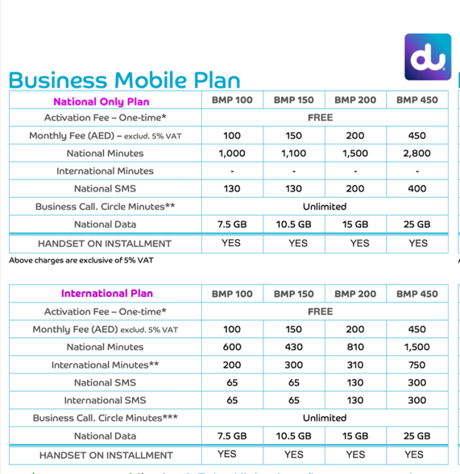

INTERNATIONAL PLANS

TABLE SHOULD BE EDITABLE FOR CONTENT AND COLOUMNS

EXECUTIVE PLANS ( MUST BE EDITABLE CONTENT AND COLUMNS)

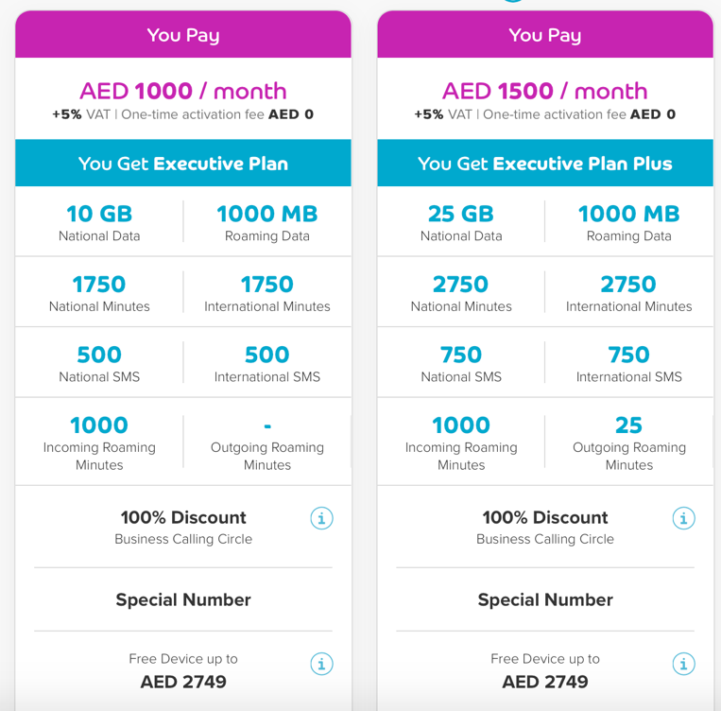

DEVICE INSTLLAMENT PLANS

(must be editable content/changeable pictures space for 10 device)

<(https://www.du.ae/smallbusiness/mobileplan/handset-offers)>

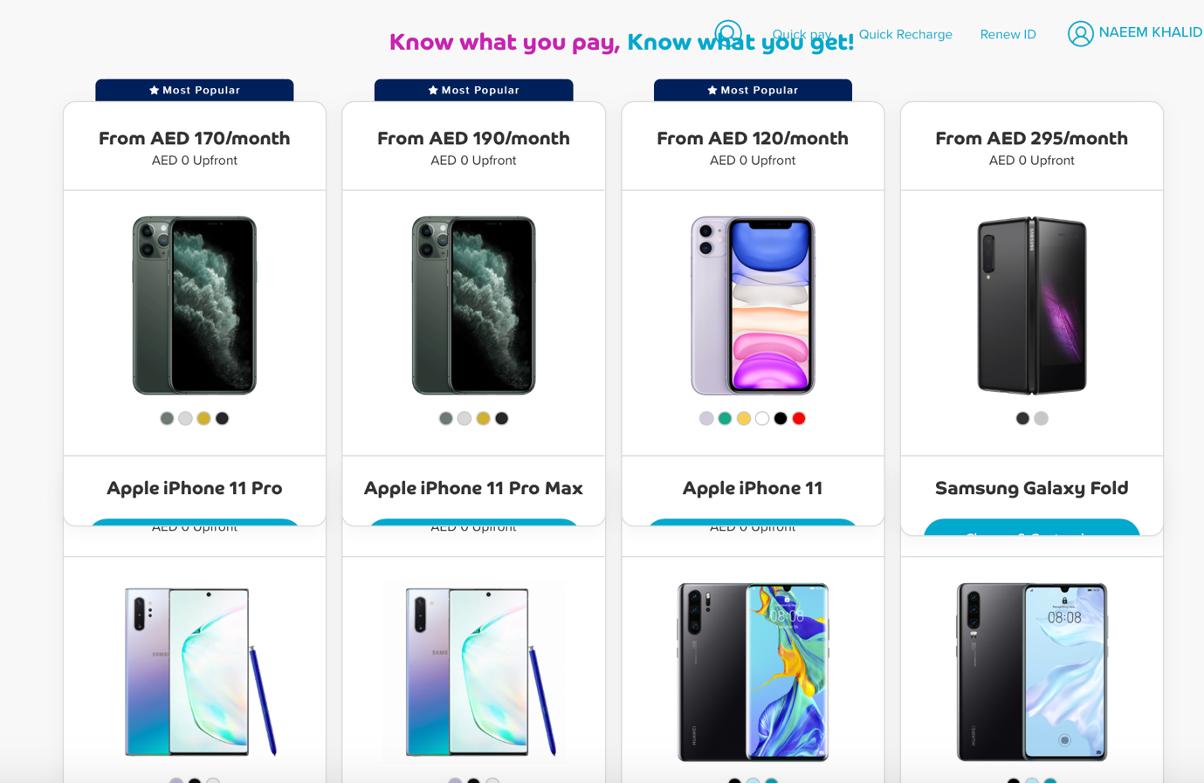

* 1. Data Sim
  2. Telemetric service ( For GPS tracking solution )
  3. Portable WIFI device

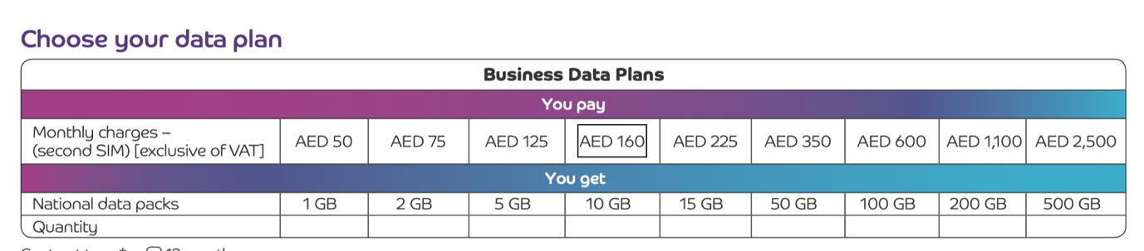

(Editable table/Content)

* 1. Telemetric service ( For GPS tracking solution )

Contact us for Enquiry

* 1. Portable WIFI device



BELOW IS A EXAMPLE :-HOW THE WEBSITE SHOULD LOOK FOR PRODUCTS AND SERVICES





EXECUTIVE PLAN

DEVICE INSTLLMENT

BUSINESS MOBILE PLAN

DATA SIM





DATA SIM

EXECUTIVE PLAN

DEVICE INSTLLMENT

BUSINESS MOBILE PLAN

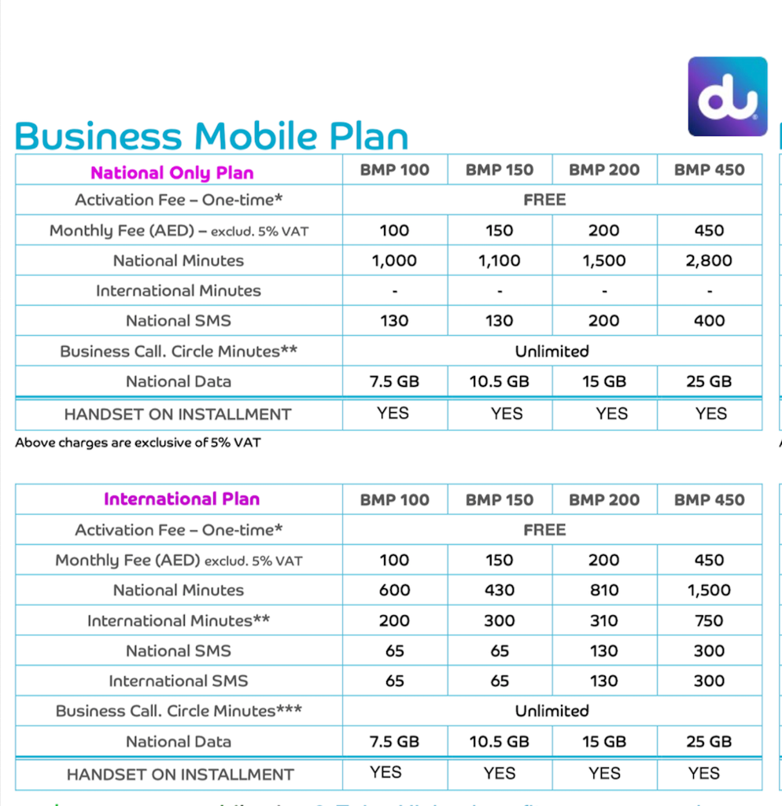National Plans International plans



* BROADBAND & LANDLINE

1. Business complete (Broadband,landline,Email,Wifi Device and much more)
2. Business Essential
3. Trunk Line (PBX)
4. ISDN 2
5. ISDN 30
6. Premium Broadband ( Dedicated Broadband )

Business complete (Broadband,landline,Email,Wifi Device and much more)

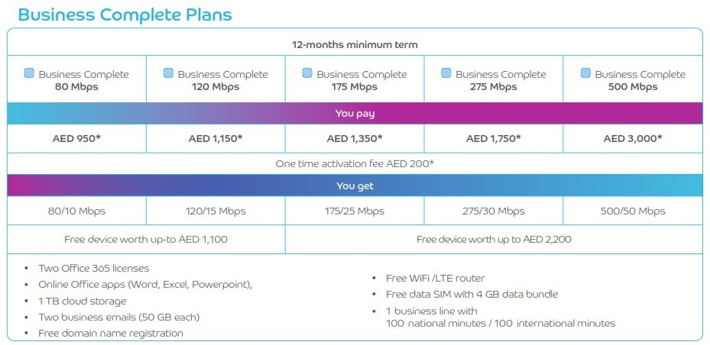

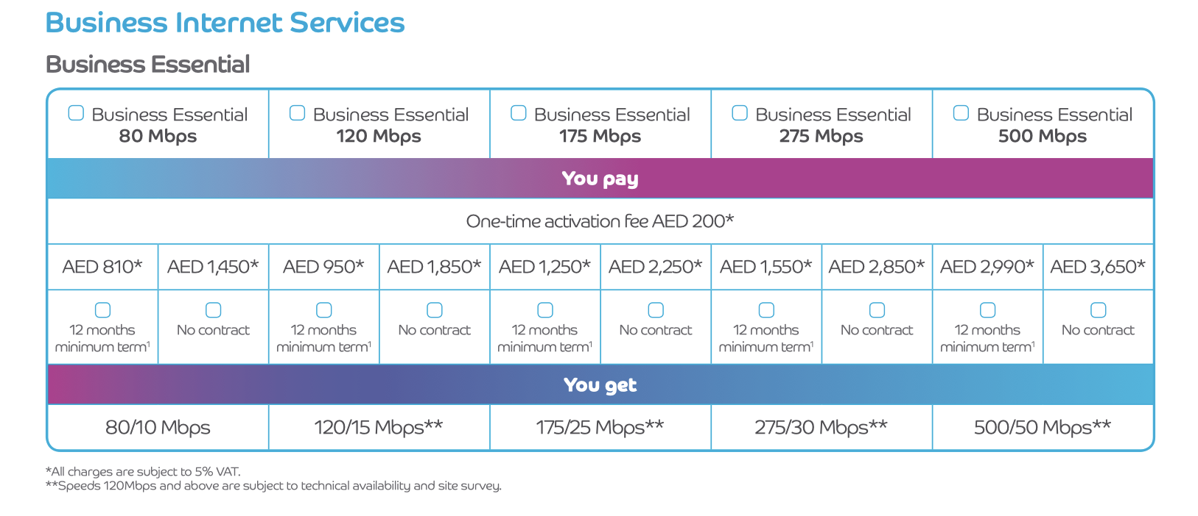Business Essential

* REWARD PROGRAME
* PERSONAL

1. Trunk Line (PBX)
2. ISDN 2
3. ISDN 30
4. Premium Broadband ( Dedicated Broadband )

Contact us !

* REWARD PROGAME

MAKE SOME SPACE IN YOUR WALLET FOR EXTRA INCOME

Refer a Friend & Earn Reward

Now any one can simply sign up to Smart link reward pregame and Make extra income @ your office or Home

500 Reward point = AED 500

We are transparent in all our transaction,. your will be notified with progress for each reference

Follow below simple steps to earn smartly

1. Install Smart link App from ( IOS / APK )
2. Sign up with mobile number or nick name
3. REFER A FRIEND (All Submissions are subject to admin approval) (Contact number , Contact name is mandatory )
4. Claim points (Claim can be only applied in multiples of 100 & minimum of AED 100 & Max 4000 in one day)(all claims will be verified and should be approved by admin)
5. Collect cash instantly ( User will receive smart code in their app or web portal which should be used to collect cash from nearest RAK bank ATM counter through mobile cash entering SMART CODE & AMOUNT) all smart code are valid only for 24 hours !)

* HOW WILL I KNOW ABOUT PROGRESS OF MY REFErals

user will receive notification on app or web portal , on approval of submission, progress, activation, rewarded point & when you claim you reward.

* HOW CAN I EARN MONEY

User should refer a friend who has business telecom requirement such as ( broadband,landline,business mobile plan etc.) once the reference is submitted all possible leads will be verified by admin for approval. After approval the reference will be in progress for activation , user will be notified about the progress. Once the reference is activated user will be rewarded with points based on total activation which can be claimed and encashed

Admin reserve all the rights to reject / approve any reference, reward points or claims at any point of time.

.( Click here to view the point sheet )

|  |  |  |
| --- | --- | --- |
|  | PRODUCT NAME | REWARD POINT(1point = AED 1) |
|  | BROADBAND | 500 POINTS |
|  | BUSINESS POSTPAID PLAN | 50% OF MRC (AED 100 PLAN = 50 POINTS) |
|  | HOME BROADBAND | 350 POINTS |

* HOW CAN I COLLECT MY REWARD POINTS AS CASH

User will receive a one-time smart code in their app or web portal which should be used to collect cash from nearest RAK bank ATM counter through mobile cash by entering SMART CODE & AMOUNT) all smart code are valid only for 24 hours !)

* WHAT IF MY SUBMIITED REFERNCE IS APPROVED

All submissions are verified by Admin for possible errors and will notify user if approved or rejected.

Admin reserve all the rights to reject or approve any reference or claims by a user.

* What if I don’t claim my points

All reward points will be accumulated in users dash board, user can encash reward points in multiples of 100 , minimum of AED 100 & maximum of AED 2000

* How much I can claim in a day

All reward points will be accumulated in users dash board, user can encash reward points in multiples of 100 , minimum of AED 100 & maximum of AED 2000.

* What is SMART CODE

Smart code is a Onetime password generated when user claim a reward point entering mobile number and password.

User has to enter First Reward point ( Amount ) & Then Smart Code ( Mobile Cash ) in to any RAK bank ATM to encash reward points

All SMART CODE are valid only for 20 hours.

Admin will not be responsible for delay or misuse of smart code.

User can contact Admin for any assistance if required.

All claims are subject to admin approval.

MAKE AN FAQ’S & TC BASED ON ABOVE INFORMAITON ON REWARD PROGRAMME

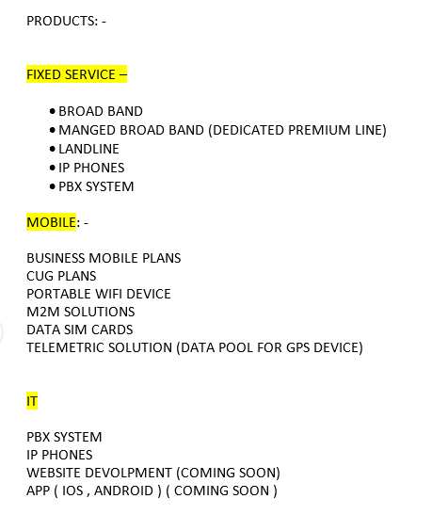

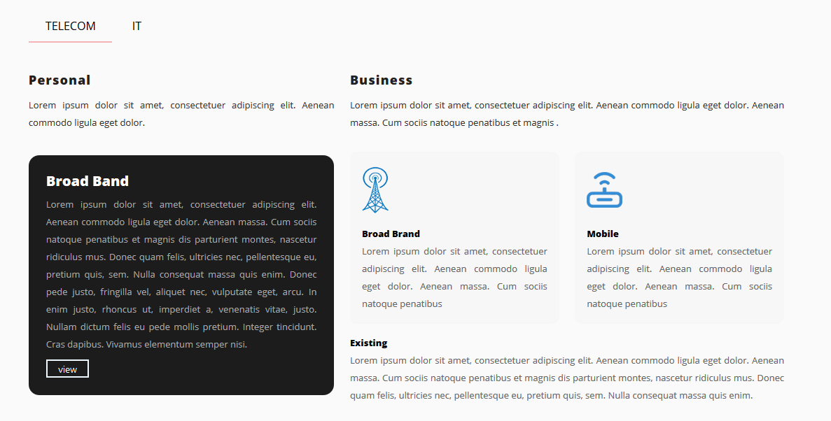

**For IT:**

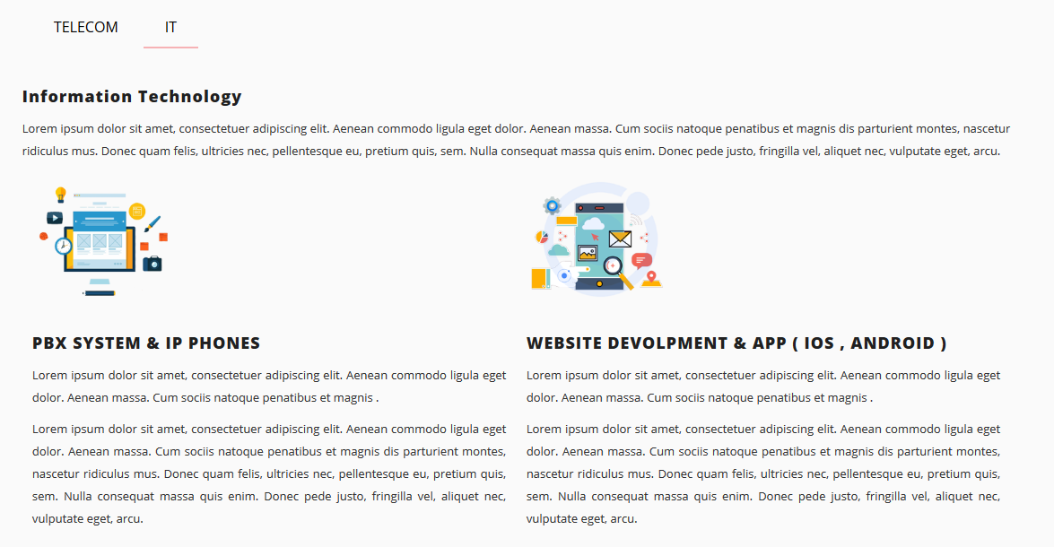

**REFER & EARN**

Proved the content for refer & earn



For below steps proved the correct headings, content and images

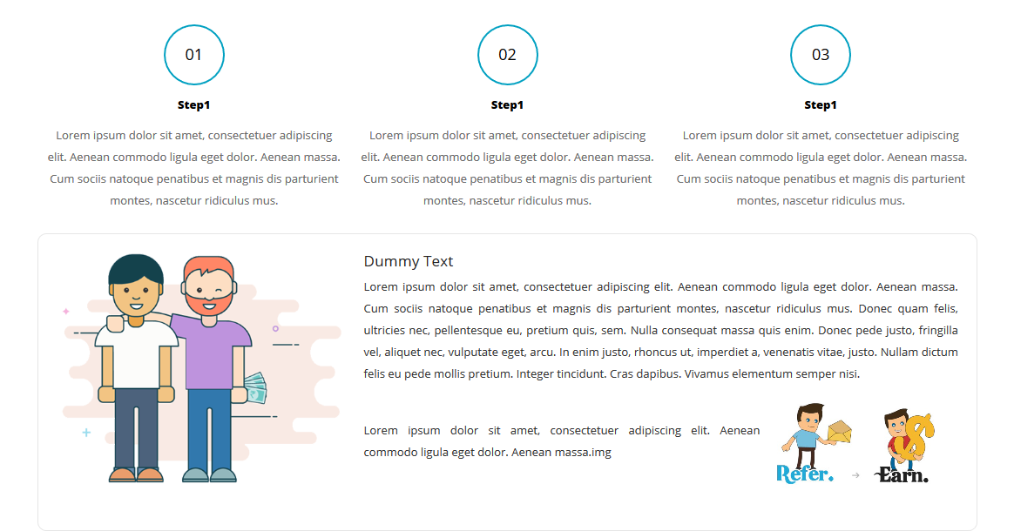

**Testimonial**

Testimonial content is required

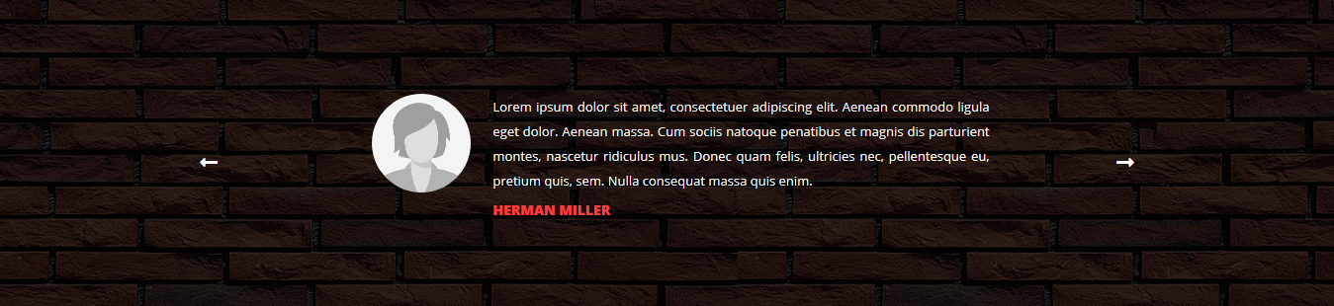

**Contact Us**

Provide the content for contact us layout

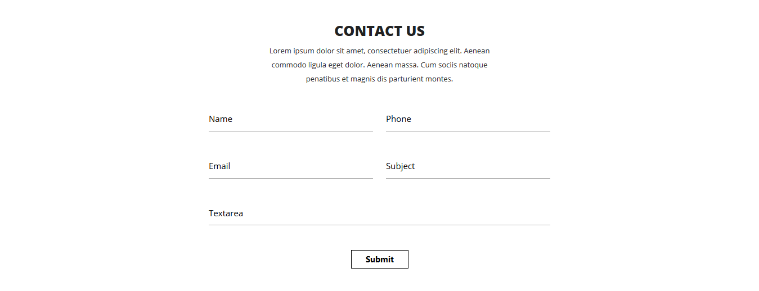

**Footer:**

Proved the address & Social media links

